ASSIGNMENT REPORT- 5

Submitted by:
LAKSHMI MAYURI KAVYA N [26120161] AKASHKUMAR A H [26120105]

Under the guidance of:
HEMA ARUNACHALAM MURTHY

For The Subject

Pattern Recognition and Machine Learning
(26AI5707)



DEPARTMENT OF ARTIFICIAL INTELLIGENCE AND DATA SCIENCE
SHIV NADAR UNIVERSITY
KALAVAKAM

OCTOBER 2026

INTRODUCTION:
This experiment implements Gaussian classification for three classes. The parameters of each class are estimated using Maximum Likelihood Estimation (MLE). Different assumptions about the covariance matrix are studied, and the influence of these assumptions on the decision boundaries and classification accuracy is observed.

METHODOLOGY:
1. Gaussian Distribution
A multivariate Gaussian distribution describes data using a mean vector μ and a covariance matrix Σ. The mean represents the centre of the class, while the covariance represents the spread and relationship between the features.

p(x|Cₖ) = 1 / [ (2π)^{(d/2)} |Σₖ|^{(1/2)} ] × exp{−½(x−μₖ)ᵀ Σₖ⁻¹ (x−μₖ) }

2. Maximum Likelihood Estimate of Mean
The MLE mean is the average of all training samples belonging to a class.

μₖ = (1/Nₖ) Σ xᵢ

3. Maximum Likelihood Estimate of Covariance
The MLE covariance measures the variation of the data around the estimated mean.

Σₖ = (1/Nₖ) Σ (xᵢ − μₖ)(xᵢ − μₖ)ᵀ

4. Gaussian Log-Likelihood
Log-likelihood is numerically more stable and converts multiplication into addition.

gₖ(x) = −½ [ d ln(2π) + ln|Σₖ| + (x−μₖ)ᵀΣₖ⁻¹(x−μₖ) ]

RESULTS AND OUTPUT:

Six Cases:
Case | Covariance Type | Accuracy
1 | Shared Isotropic | 99.72%
2 | Different Isotropic | 99.43%
3 | Shared Diagonal | 99.02%
4 | Different Diagonal | 99.43%
5 | Shared Full Covariance | 98.38%
6 | Different Full Covariance | 99.23%

Case1: Shared Isotropic Covariance

Total samples generated: 30000
Training samples: 24000
Testing samples : 6000
Estimated Means
Class 1: [-2.007 -1. ]
Class 2: [ 3.977 -0.011]
Class 3: [1.005 5.007]

Estimated Covariance Matrices
Class 1:
[[1.005 0. ]
[0. 1.005]]
Class 2:
[[1.005 0. ]
[0. 1.005]]
Class 3:
[[1.005 0. ]
[0. 1.005]]

Confusion Matrix
[[1995 4 1]
[ 2 1995 3]
[ 1 6 1993]]

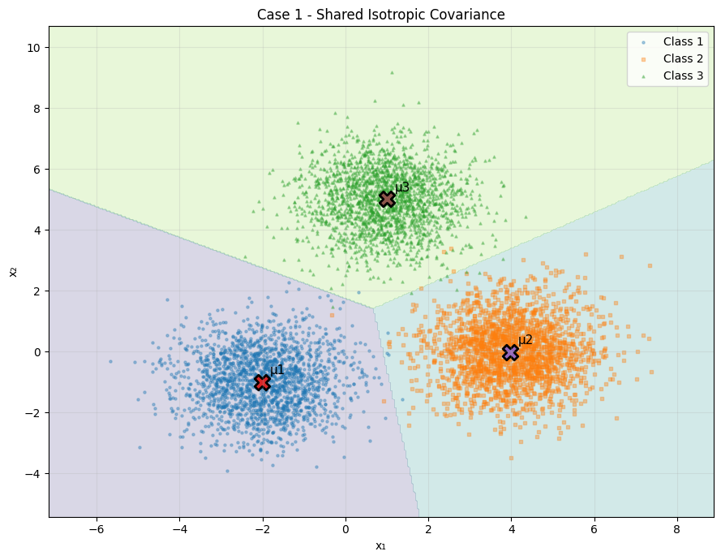

Case 2: Different Isotropic Covariance

Total samples generated: 30000
Training samples: 24000
Testing samples : 6000
Estimated Means
Class 1: [-2.003 -1.006]
Class 2: [4.003 0.008]
Class 3: [1.003 5.007]

Estimated Covariance Matrices
Class 1:
[[0.991 0. ]
[0. 0.991]]
Class 2:
[[1.977 0. ]
[0. 1.977]]
Class 3:
[[0.499 0. ]
[0. 0.499]]

Confusion Matrix
[[1990 10 0]
[ 16 1980 4]
[ 0 4 1996]]

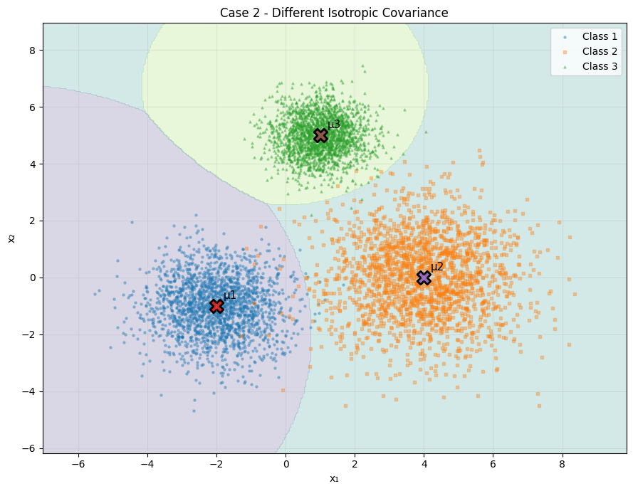

Case 3 - Shared Diagonal Covariance

Total samples generated: 30000
Training samples: 24000
Testing samples : 6000
Estimated Means
Class 1: [-1.998 -1.003]
Class 2: [4.01 0.003]
Class 3: [1.01 5.018]

Estimated Covariance Matrices
Class 1:
[[0.991 0. ]
[0. 1.998]]
Class 2:
[[0.991 0. ]
[0. 1.998]]
Class 3:
[[0.991 0. ]
[0. 1.998]]

Confusion Matrix
[[1992 2 6]
[ 3 1976 21]
[ 10 17 1973]]

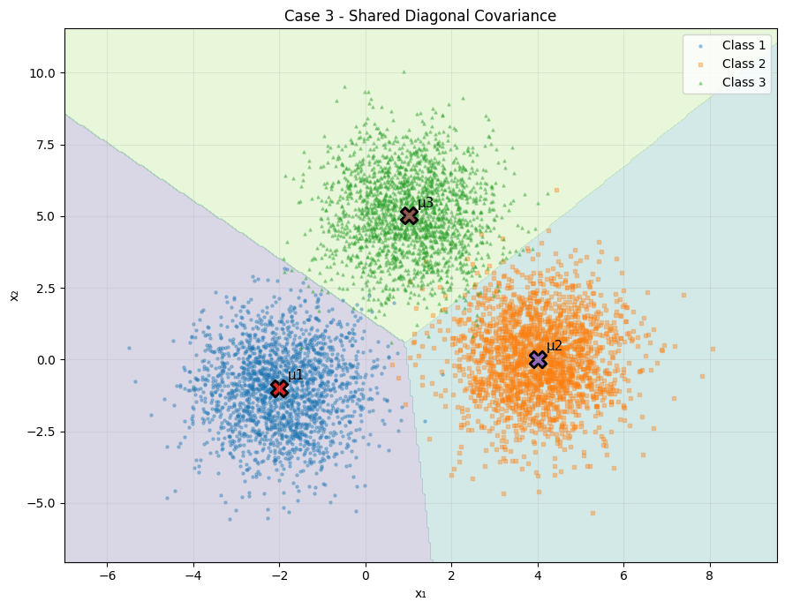

Case 4 - Different Diagonal Covariance

Total samples generated: 30000
Training samples: 24000
Testing samples : 6000
Estimated Means
Class 1: [-2.004 -0.998]
Class 2: [ 3.986 -0.011]
Class 3: [0.994 5.002]

Estimated Covariance Matrices
Class 1:
[[0.984 0. ]
[0. 2.001]]
Class 2:
[[2.025 0. ]
[0. 1.007]]
Class 3:
[[1.486 0. ]
[0. 0.499]]

Confusion Matrix
[[1987 10 3]
[ 17 1982 1]
[ 1 2 1997]]

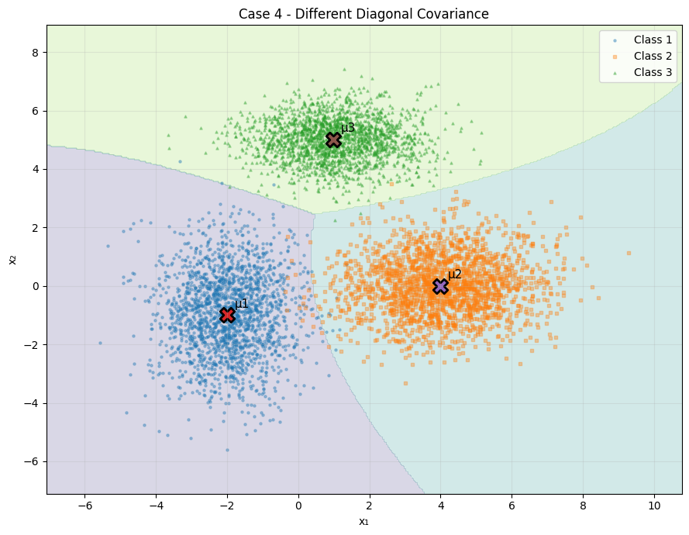
Case 5 - Shared Full Covariance

Total samples generated: 30000
Training samples: 24000
Testing samples : 6000
Estimated Means
Class 1: [-2.002 -1.002]
Class 2: [ 4.001 -0.013]
Class 3: [1.009 5.007]

Estimated Covariance Matrices
Class 1:
[[ 2.006 -0.813]
[-0.813 1.512]]
Class 2:
[[ 2.006 -0.813]
[-0.813 1.512]]
Class 3:
[[ 2.006 -0.813]
[-0.813 1.512]]

Confusion Matrix
[[1990 10 0]
[ 7 1958 35]
[ 0 45 1955]]

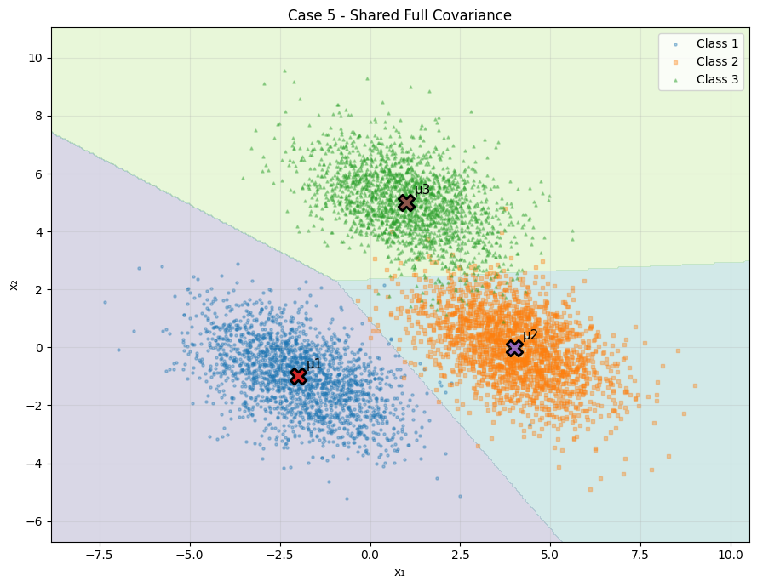
Case 6 - Different Full Covariance

Total samples generated: 30000
Training samples: 24000
Testing samples : 6000
Estimated Means
Class 1: [-1.97 -0.999]
Class 2: [4.009 0.027]
Class 3: [1.067 5.017]

Estimated Covariance Matrices
Class 1:
[[ 2.048 -0.818]
[-0.818 1.481]]
Class 2:
[[1.491 0.519]
[0.519 1.959]]
Class 3:
[[2.043 0.709]
[0.709 0.984]]

Confusion Matrix
[[1984 11 5]
[ 22 1973 5]
[ 1 2 1997]]
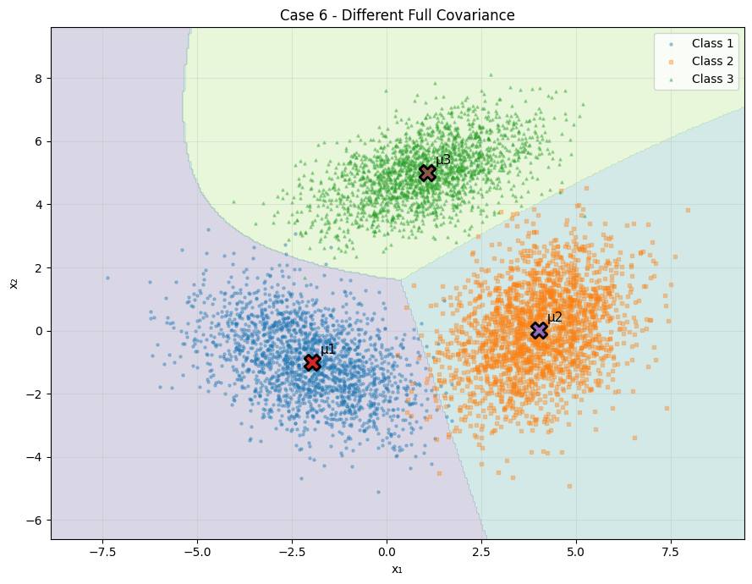

Part 2 – Gaussian Classification on 2-D Dataset
A separate 2-D dataset containing three classes was classified using MLE Gaussian classification. The dataset contains 1,050 samples, with 350 samples in each class. An 80:20 split gives 840 training samples and 210 testing samples.

MLE Estimated Parameters:

Class | MLE Mean | MLE Covariance
1 | [ 591.241 1441.262] | [[24052.371 -4028.556]  [-4028.556 48674.343]]
2 | [ 343.687 2035.359] | [[ 6295.738 -6580.945]  [-6580.945 40633.934]]
3 | [ 405.657 1200.987] | [[ 18779.963 26963.836]  [ 26963.836 136415.665]]

CONFUSION MATRIX:

[[63 2 5]
[ 4 64 2]
[11 2 57]]
Accuracy: 87.62%

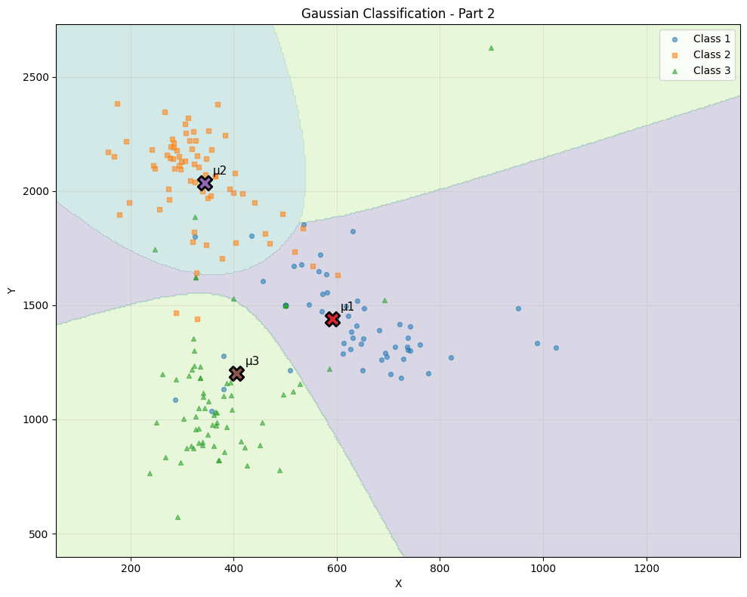

Training samples : 840
Testing samples : 210
Correct predictions: 184
Incorrect predictions: 26
Conclusion:
Gaussian classification was implemented using Maximum Likelihood Estimation. The experiment involved estimating the class means and covariance matrices and then used Gaussian log-likelihood to classify the unknown samples. Six different covariance assumptions were compared on the basis of their decision boundaries, confusion matrices, and accuracy. In the experiment using generated data, very high accuracy was obtained, whereas with the separate 2-D dataset the accuracy was 87.62%. The experiment shows how the selection of the covariance model influences the shape of the decision regions and the classification performance.

